

Leadership Program for Women in Computer Sciences 2016 (WeLead)
Application for Likestillingsmidler 2016
Reference: 2015/19469

Katja Abrahamsson (Project Coordinator) and Letizia Jaccheri (Project Responsible)
Department of Computer and Information Science, NTNU

Harald Øverby (co-responsible),
Department of Telematics, NTNU

Laura Georg (co-responsible),
Department of Information and Media Technology, Gjøvik University College becoming in January 2016 part of NTNU

14.12.2015

1 Overview
This major goal of this application for Likestillingsmidler 2016 is to help female computer scientists employed by NTNU to advance their scientific careers. We are applying for 638.000 NOK for 2016 to implement the following key actions: 1) mentoring, 2) networking, 3) dissemination and funding.

Leadership program for women in computer sciences (WeLead) started in 2014 by Department of Computer and Information Science (IDI). In 2015 the Telematics department (ITEM) joined. For 2016, we plan to include NTNU’s new units in Gjøvik (Department of Information and Media Technology), HiST and Ålesund.

The leadership program involves professional training to be able to manage the gender biases that are embedded in the current system, and be more strategic in scientific career development and advancement. As an example, a training session with an organizational psychologist on "Leadership, gender, and culture” was organized this year to address this. Furthermore, another important focus is to strengthen internal and external networking. The program wants therefore to collaborate with other similar programs locally and internationally and regularly invites highly recognized international female scientists, such as in 2015 Dr. Leila Alem from Australia and Prof. Gabriella Dodero from Italy. They gave inspirational talks and acted as mentors for our program participants.

The program has also participated in the Grace Hopper Conference (GHC) together with over 12,000 other female colleagues. NTNU’s goal was to attract prospective PhD students and Post Docs for our programs as well as to network with future colleagues. Attracting new female employees is tough with competition from high-profile companies such as Facebook and Google who emphasise their strong interest to hire women in computer science positions.

Based on the feedback from the participants gathered in October 2015, and interest shown by other CS units, the program is on the right track. The participants appreciate the extra effort that is put in supporting them in their career advancement. As an example, Kerstin Bach, one of the program participants, said that the program had been an inspiration and helped her to reflect on where she stands in her career, and how she can support more women to aim at top leadership positions in the field of science.

The program involves today 20 active female scientists at IDI and ITEM. The program aims at involving 5-8 more from Gøvik, from HiST 3-5 scientists and from Ålesund 1-2 scientists in 2016.

Likestillingsmidler 2016 will be used to secure the operation of the program until external funding can be attracted. The program seeked funding from BALANSE 2015 but was not funded. Currently there are no calls open in NFR. The program also seeks to apply European Union funding.

2 Motivation
It has been long recognized that more women need to be attracted to Computer Science (CS) programs globally (Frenkel, 1990). However, there is an overwhelming research evidence showing that the trend has taken the opposite direction. In 1984, 37% of Computer Science degrees in the U.S. were awarded to women and in 2014; the number dropped to 14 percent (Zweben & Bizot, 2013). As of today in Norway, only 26% of professor positions are held by women (Rønnen, 2015). Gender balance in academic positions is a recognized goal in the Norwegian society.

The table below lists the percentage of women in person years at the Faculty of Information Technology, Mathematics and Electrical Engineering (IME), and for the two departments in this program. There is a significant gap between the number of women in temporary and permanent academic positions. The leadership program needs therefore focus on temporary staff to make them become more aware of the importance of strategic career planning and development.

Person years for the Faculty and Departments: Source http://dbh.nsd.uib.no
Position category | Faculty IME |  | Department CS |  | Department Telematics
 | Person years | % Women | Person years | %  Women | Person years | % Women
Temporary PhD and Post Docs | 244.3 | 19.8 | 41.1 | 21.5 | 17.6 | 38.5
Research and Teaching Positions | 165.3 | 13.5 | 42.1 | 14 | 14.4 | 8.3

In Gjøvik, Department of Information and Media Technology (IMT), the numbers are as follows:

Position category | Faculty IMT
 | Person years | % Women
Temporary PhD and Post Docs | 31.0 | 19.4
Research and Teaching Positions | 48.7 | 13.6

Positon category | NISLab |  | MTL
 | Person years | % Women | Person years | % Women
Temporary PhD and Post Docs | 21.0 | 16.7 | 10.0 | 20.0
Research and Teaching Positions | 18.3 | 24.0 | 30.4 | 7.2

Previous experience from other leadership training programs is that they are effective in empowering women to take leadership positions, and focusing on women already in an academic position within the fields of Telematics and Computer Science (including Information Security) department represents a key opportunity (World Bank, 2012) that this program will seek to utilize.

3 Goals
The general goals of our program include enhancing the leadership and strategic skills of the participants, increasing women networking to be able to take a firm stand in scientific positions and encouraging women to take top science and technology leadership positions and be mentors to fellow women.

The specific goals for 2016 are as follows:
- Increase program participants’ mentoring. The goal for each is to have their own internationally recognized career mentor. As part of this, we seek also to offer a recognition for highly successful females in top in science or technology.
- Broaden program participants’ networking capacity nationally and internationally by participating to Norwegian, European and an American networking event & career fair.
- Raise program awareness locally, nationally and internationally. The goal is to stabilize a more permanent funding base for the Leadership Program according to the roadmap defined (See Section 6).

4 Action Plan & Measures
The upcoming steps in the program are to involve more men in order to increase awareness of the challenges raised, increase the attractiveness of PhD programs in CS, Telematics and Information and Media Technology, and to offer more mentoring support for women. However, to be able to continue, and extend the program, long term stable funding is needed. This has been a major challenge for similar projects, and there is a strong need to provide more funding opportunities for programs with an aim of enhancing women's advancement in their scientific careers (Waylen, 2013).

Based on the goals stated above, we have identified the following Actions to be taken to achieve them. We have also included measures for each Action to determine their success.

Goal | Action | Measure | Notes
Mentoring (1) | - 4 visiting scholars. Recognized internationally visible female scientists.  - 3 Training sessions  - Recognize an international woman leader | - Each participant has their own mentor  - One NTNU recognition offered | - Trainings 1 day + 2*0,5 day  - The recognition is within the the field of computer science. Acts as a role model for women in the program.
Networking (2) | - participation to 2-3 international events  - Career networking with Ada project & Security Divas  - Social media networking and planned visibility increase | - Program participants’ participation satisfaction  - # new network contacts  - Linkedin profile performance statistics | - 1st European Celebration of Women in Computing  - IEEE Conf. on Technology Management (TRD)
Awareness (3) | - Rebranding the program to Women Leadership Academy to broaden the impact  - Raise funding  - Attract industrial sponsorship  - Collaborate and support in research at NTNU targeted to leadership and IT leadership. | - Women leadership program recognized as Leadership Academy  - Funding application submitted planned and submitted to EU and NFR if applicable  - 50.000NOK raised as direct industrial sponsor | The industrial sponsorship is used to promote events such as a keynote at ICE 2016

5 Budget
The program has so far been mostly self-funded. In 2015, the likestillingsmidler funding was 200.000NOK and the remainder came from IDI (50% project manager + 40.000NOK). For 2016 the budget has been envisioned as presented in the following table.



6 Five-year Roadmap
The leadership program for women in computer science is dedicated to reach ambitious, concrete and tangible goals within 5 years. The long-term goal is to make NTNU internationally leading in promoting female scientists’ career development in computer science. We will reach this by involving a broader community of computer scientists within NTNU. The figure below identifies the main goals for each operational year starting 2014.

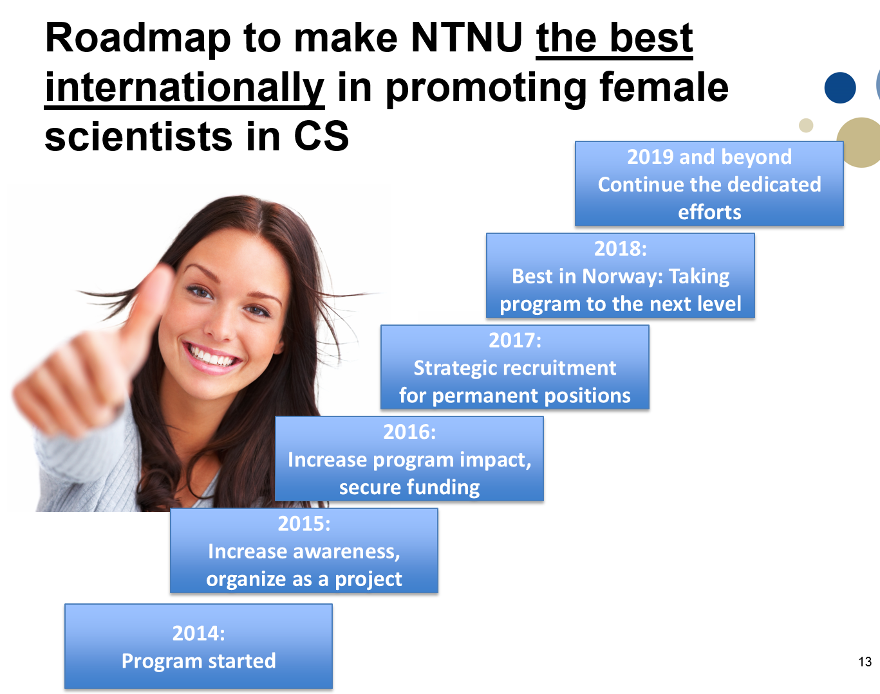

7 Summary
The leadership program for women in computer science was initiated in 2014 by IDI. The program has grown since then to include ITEM and in 2016 also the three fusion partners in Gjøvik, HiST and Ålesund. The success of the first two years have motivated us to continue and strengthen the program and move forward to introduce the 5-year roadmap and the new concept of the “leadership academy for women in computer sciences at NTNU”.

References
Frenkel, K. A. (1990). Women and computing. Communications of the ACM, 33, 34–46. doi:10.1145/92755.92756
Waylen, G. (2013). Informal Institutions, Institutional Change, and Gender Equality. Political Research Quarterly, 67(1), 212–223. doi:10.1177/1065912913510360
Zweben, B. S., & Bizot, B. (2013). 2012 Taulbee Survey. Computing Research News, 25(5), 11–60.

Links
Rønnen, K.P. (2015). Women discriminated in the top positions in the Norwegian academia (In Norwegian), Dagens Perspektiv, http://www.dagensperspektiv.no/2015/kvinner-diskrimineres-pa-toppen-i-norsk-akademia, accessed 26.11.2015
World Bank. (2012). Gender equality in development. World Development Report 2012. doi:10.1080/13552070512331332273

